COS10029 Fundamentals of Programming TP 2 2024

Assignment 2 report

Name: Sovithyea Prach Student ID:105270743

Lab class: Wednesday / 4:30 / TD 216 Teacher: Dr. Prince

Due Date: Monday 9th September 2024 at 11:59 pm

Date Submitted: Saturday 7th September 2024

Question 1

Program description

The following is a C++ program to check a credit card number via the Lunh Algorithm. It takes in inputs of a sequence of one-digit numbers representing a credit card and stores them in an array. The program checks if the digits are valid to be a credit card via findSum1, findSum2, and checksum to validate the credit card.

Source code:

IMPORTANT: DON’T GIVE THE SCREENSHOT OF THE CODE (COPY AND PASTE THE CODE)

#include <iostream>
#define max_size 20
using namespace std;

// function to calculate sum1
int findSum1(int array[], int size)
{
int sum1 = 0;

cout << "Numbers for sum1 are ";

for (int i = size - 2; i >= 0; i -= 2) {
int doubled = array[i] * 2; // double the value of the digit

// if the result is a two-digit number, sum its digits
if (doubled > 9) {
doubled = (doubled / 10) + (doubled % 10);
}

sum1 = sum1 + doubled;
cout << array[i] << " ";
}

cout << "\nSum1 is " << sum1 << endl;
return sum1;
}

// no doubling in sum2
int findSum2(int array[], int size)
{
int sum2 = 0;

cout << "Numbers for sum2 are ";

for (int i = size - 3; i >= 0; i -= 2) {
sum2 = sum2 + array[i];
cout << array[i] << " ";
}

cout << "\nSum2 is " << sum2;
return sum2;
}

// function to calculate the checksum and validate the credit card
void validateCreditCard(int sum1, int sum2, int lastDigit) {
int total = sum1 + sum2;
int checksum = (total * 9) % 10;

cout << "\nChecksum is " << checksum << endl;

cout << "Last digit on credit card is " << lastDigit << endl;
if (checksum == lastDigit) {
cout << "Check sum " << checksum << " and the last digit " << lastDigit << " are the same: Valid credit card number." << endl;
} else {
cout << "Check sum " << checksum << " and the last digit " << lastDigit << " are not the same: Invalid credit card number." << endl;
}
}

int main()
{
int array[max_size];
int size = 0;
int digit;

cout << "Enter a series of one-digit positive numbers (end with -1): " << endl;

while (size < max_size)
{
cin >> digit;

if (digit == -1) {
break;
}

// check if the input is a valid single-digit positive number
if (digit >= 0 and digit <= 9)
{
array[size++] = digit; // store the digit in the array and increment the size
}
else
{
cout << "Please enter a valid one-digit positive number." << endl;
}
}

// output the entered digits stored in the array
cout << "\nCredit card number is: ";
for (int i = 0; i < size; i++)
{
cout << array[i];
}
cout << endl;

// calculate and print sum1
int sum1 = findSum1(array, size);

// calculate and print sum2
int sum2 = findSum2(array, size);

// validate the credit card
validateCreditCard(sum1, sum2, array[size - 1]);

return 0;
}

Screenshots showing working program (Show all possible outcome):
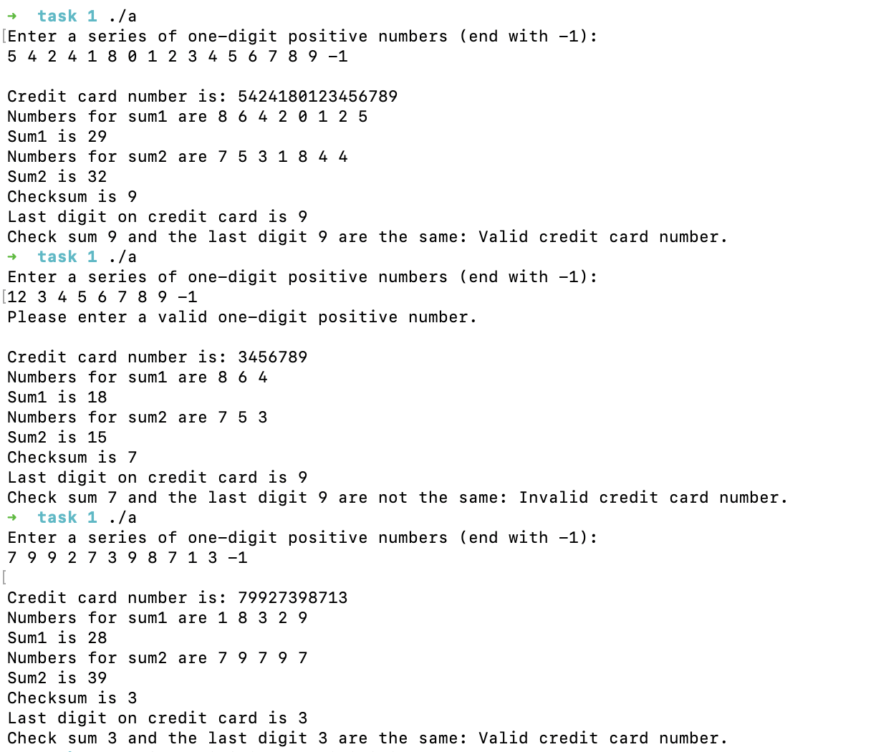

Question 2

Program description

This C++ program allows the user to manage and display information on 3 different music albums, the artist, album name, genre, and songs all from a text file called ‘albums.txt’. Its main purpose is to be able to read the album data, display the albums, update the album information, and finally play the ‘tracks’.

Source code:

IMPORTANT: DON’T GIVE THE SCREENSHOT OF THE CODE (COPY AND PASTE THE CODE)

#include <iostream>
#include <fstream>
#include <string>
using namespace std;

enum Genre
{
RAP = 0,
POP = 1,
KRNB = 2
};

struct Album
{
string artistName;
string albumName;
Genre genre;
int numberOfTracks;
string tracks[3];
string trackFilePaths[3];
};

// takes a genre and turns it into a string and converts it into its enum value
Genre getGenreFromString(string &genreStr)
{
if (genreStr == "POP") return POP;
if (genreStr == "KRNB") return KRNB;
if (genreStr == "RAP") return RAP;
}

// reads the album data from the function
int readAlbum(Album albums[])
{
string filePath;
cout << "Enter a file path to an Album: ";
cin >> filePath; // enter the name of file (albums.txt)

ifstream inFile(filePath);

if (inFile.fail())
{
cout << "Error opening file\n";
exit(1);
}

int i = 0;
while(inFile >> albums[i].artistName >> albums[i].albumName)
{
string genreStr;
inFile >> genreStr;
albums[i].genre = getGenreFromString(genreStr);

inFile >> albums[i].numberOfTracks;

for (int j = 0; j < albums[i].numberOfTracks; j++) {
inFile >> albums[i].tracks[j];
inFile >> albums[i].trackFilePaths[j];
}

i++;
}

inFile.close();
return i;
}

// displays the information for the artist and albums in the file
void displayAll(Album albums[], int albumCount)
{
for(int i = 0; i < albumCount; i++)
{
cout << i + 1 << ": Title: " << albums[i].albumName
<< " Artist: " << albums[i].artistName
<< endl;
}
}
// makes it possible to update the names of the album
void updateAlbum(Album albums[], int albumCount)
{
int albumChoice;
for(int i = 0; i < albumCount; i++)
{
cout << i + 1 << ": Title: " << albums[i].albumName
<< " Artist: " << albums[i].artistName << endl;
}

cout << "Enter the Album to edit: ";
cin >> albumChoice;

if (albumChoice > 0 and albumChoice <= albumCount)
{
int albumIndex = albumChoice - 1; // because the data is stored in the array as 0, 1, 2 not 1, 2, 3
int selection;
cout << "Editing Album: " << albums[albumIndex].albumName << endl;

cout << "What to edit: \n1.Title\n2.Genre\nEnter selection: ";
cin >> selection;

if (selection == 1)
{
cout << "Enter new album name: ";
cin.ignore();
string newAlbumName;
getline(cin, newAlbumName);

if (!newAlbumName.empty())
{
albums[albumIndex].albumName = newAlbumName;
cout << "Album name updated to: " << newAlbumName << endl;
}
}
else if (selection == 2)
{
cout << "code not fully implemented :(( " << endl;
}
}
else if (albumChoice == 0) {
cout << "Returning to Main Menu..." << endl;
}
else
{
cout << "Invalid album choice!" << endl;
}
}

// displays the second menu, to display the albums
void displayAlbumsMenu(Album albums[], int albumCount)
{
int choice;
do
{
cout << "\nDisplay Album Menu:" << endl;
cout << "1. Display all Albums" << endl;
cout << "2. Display Albums by Genre" << endl;
cout << "3. Back to Main Menu" << endl;
cout << "Please enter your choice: ";
cin >> choice;

switch (choice)
{
case 1:
displayAll(albums, albumCount);
break;

case 2:
{
int genreChoice;
cout << "1.POP\n2.KRnB\n3.RAP ";
cout << "\nPick a genre: ";
cin >> genreChoice;

if(genreChoice == 1)
{
cout <<"\nTitle: " << albums[0].albumName
<<" Artist: " << albums[0].artistName
<<" Genre: POP";
}
else if(genreChoice == 2)
{
cout <<"\nTitle: " << albums[1].albumName
<<" Artist: " << albums[1].artistName
<<" Genre: KRnB";
}
else if(genreChoice == 3)
{
cout <<"Title: " << albums[2].albumName
<<" Artist: " << albums[2].artistName
<<" Genre: RAP"
<< endl;
}
break;
}

case 3:
cout << "Returning to Main Menu..." << endl;
break;

default:
cout << "Invalid choice! Please try again." << endl;
}
} while (choice != 3);
}

// selecting an album to play
void albumSelection(Album albums[], int &albumCount)
{
int choice;

do
{
cout <<"\n1. Title: " << albums[0].albumName << " Artist: " << albums[0].artistName << " Genre: POP" << endl;
cout <<"2. Title: " << albums[1].albumName << " Artist: " << albums[1].artistName << " Genre: KRnB" << endl;
cout <<"3. Title: " << albums[2].albumName << " Artist: " << albums[2].artistName << " Genre: RAP" << endl;
cout <<"4. Exit this page"<<endl;
cout <<"Enter an Album number: ";
cin >> choice;

switch (choice)
{
case 1:
{
int playingSong;

cout <<"\nTitle: " << albums[0].albumName << " Artist: " << albums[0].artistName << " Genre: POP" << endl;
cout<<"1. Trackname: " << albums[0].tracks[0] << endl;
cout<<"2. Trackname: " << albums[0].tracks[1] << endl;
cout<<"3. Trackname: " << albums[0].tracks[2] << endl;
cout << "Select a tack to play: ";
cin >> playingSong;

if(playingSong == 1)
{
cout << "Playing track: " << albums[0].tracks[0] <<" from album " << albums[0].albumName << endl;
}
if(playingSong == 2)
{
cout << "Playing track: " << albums[0].tracks[1] <<" from album " << albums[0].albumName << endl;
}
if(playingSong == 3)
{
cout << "Playing track: " << albums[0].tracks[2] <<" from album " << albums[0].albumName << endl;
}
break;
}

case 2:
{
int playingSong;

cout <<"\nTitle: " << albums[1].albumName << " Artist: " << albums[1].artistName << " Genre: KRnb" << endl;
cout<<"1. Trackname: " << albums[1].tracks[0] << endl;
cout<<"2. Trackname: " << albums[1].tracks[1] << endl;
cout << "Select a tack to play: ";
cin >> playingSong;

if(playingSong == 1)
{
cout << "Playing track: " << albums[1].tracks[0] <<" from album " << albums[1].albumName << endl;
}
if(playingSong == 2)
{
cout << "Playing track: " << albums[1].tracks[1] <<" from album " << albums[1].albumName << endl;
}
break;
}
case 3:
{
int playingSong;

cout <<"\nTitle: " << albums[2].albumName << " Artist: " << albums[2].artistName << " Genre: RAP" << endl;
cout<<"1. Trackname: " << albums[2].tracks[0] << endl;
cout << "Select a tack to play: ";
cin >> playingSong;

if(playingSong == 1)
{
cout << "Playing track: " << albums[2].tracks[0] <<" from album " << albums[2].albumName << endl;
}
break;
}
case 4:
cout << "Exiting the application..." << endl;
break;
default:
cout << "Invalid choice! Please try again." << endl;
}
} while(choice != 4);

}

// the main menu
void menu(Album albums[], int &albumCount)
{
int choice;

do
{
cout << "\nMain Menu:" << endl;
cout << "1. Read in Albums" << endl;
cout << "2. Display Albums" << endl;
cout << "3. Select an Album to Play" << endl;
cout << "4. Update an Existing Album" << endl;
cout << "5. Exit the Application" << endl;
cout << "Please enter your choice: ";
cin >> choice;

switch (choice)
{
case 1:
{
albumCount = readAlbum(albums);
cout << albumCount << " albums read from file." << endl;
break;
}
case 2:
displayAlbumsMenu(albums, albumCount);
break;
case 3:
albumSelection(albums, albumCount);
break;
case 4:
updateAlbum(albums, albumCount);
break;
case 5:
cout << "Exiting the application..." << endl;
break;
default:
cout << "Invalid choice! Please try again." << endl;
}
} while (choice != 5);
}

int main()
{
Album albums[100]; // max amount of array to 100
int albumCount = 0;

menu(albums, albumCount);

return 0;
}

Screenshots showing working program (Show all possible outcome):

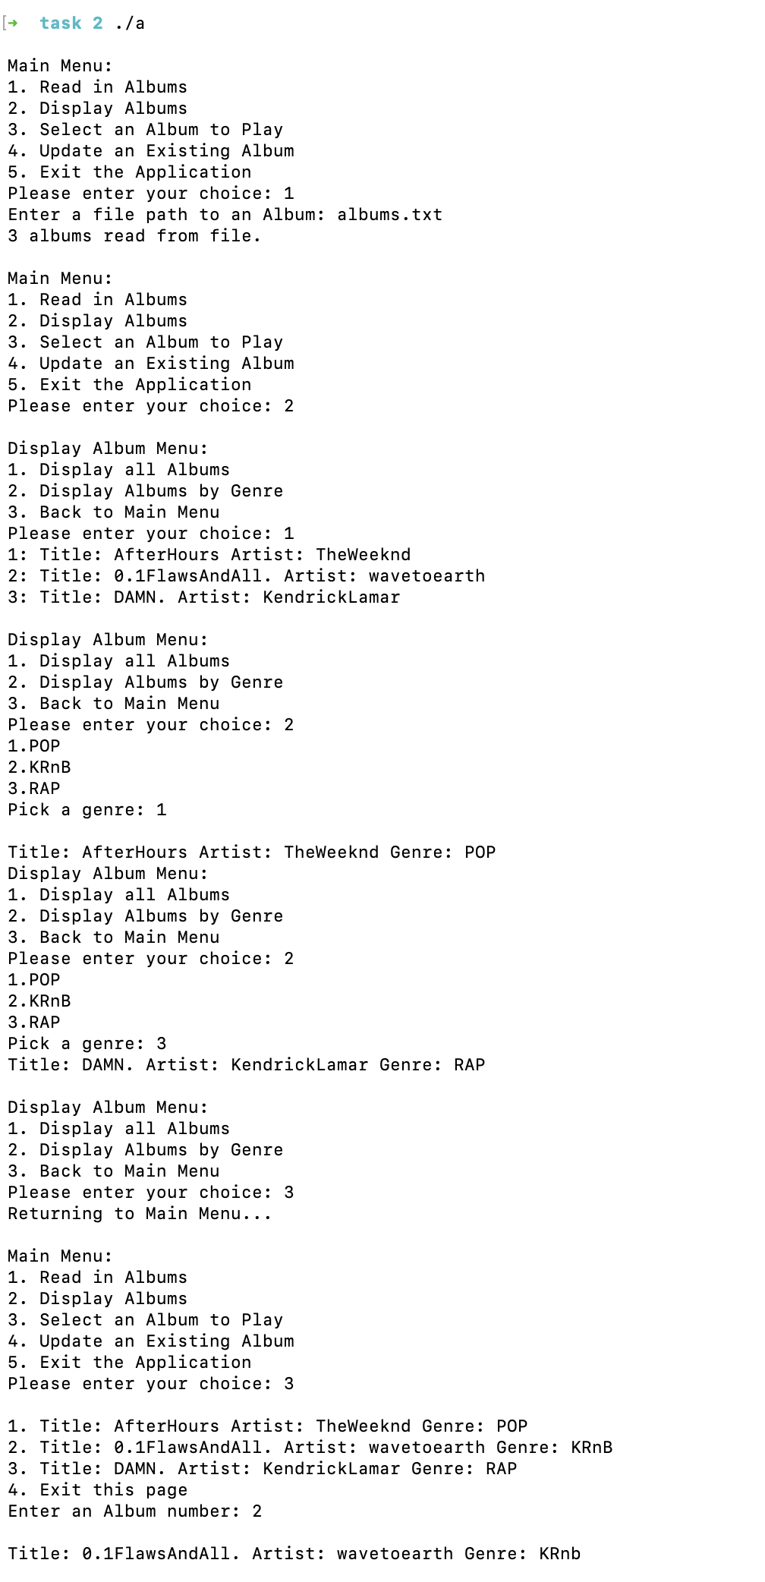
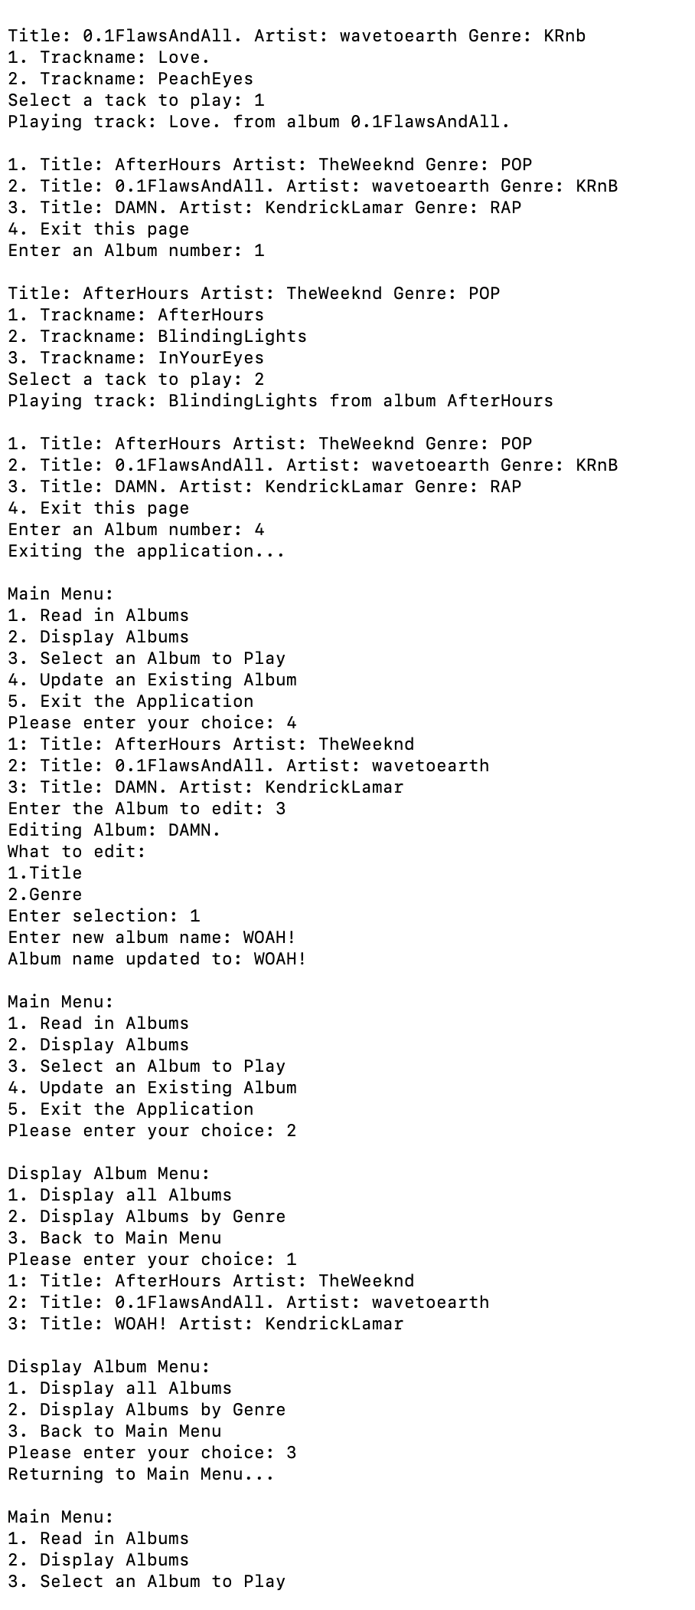

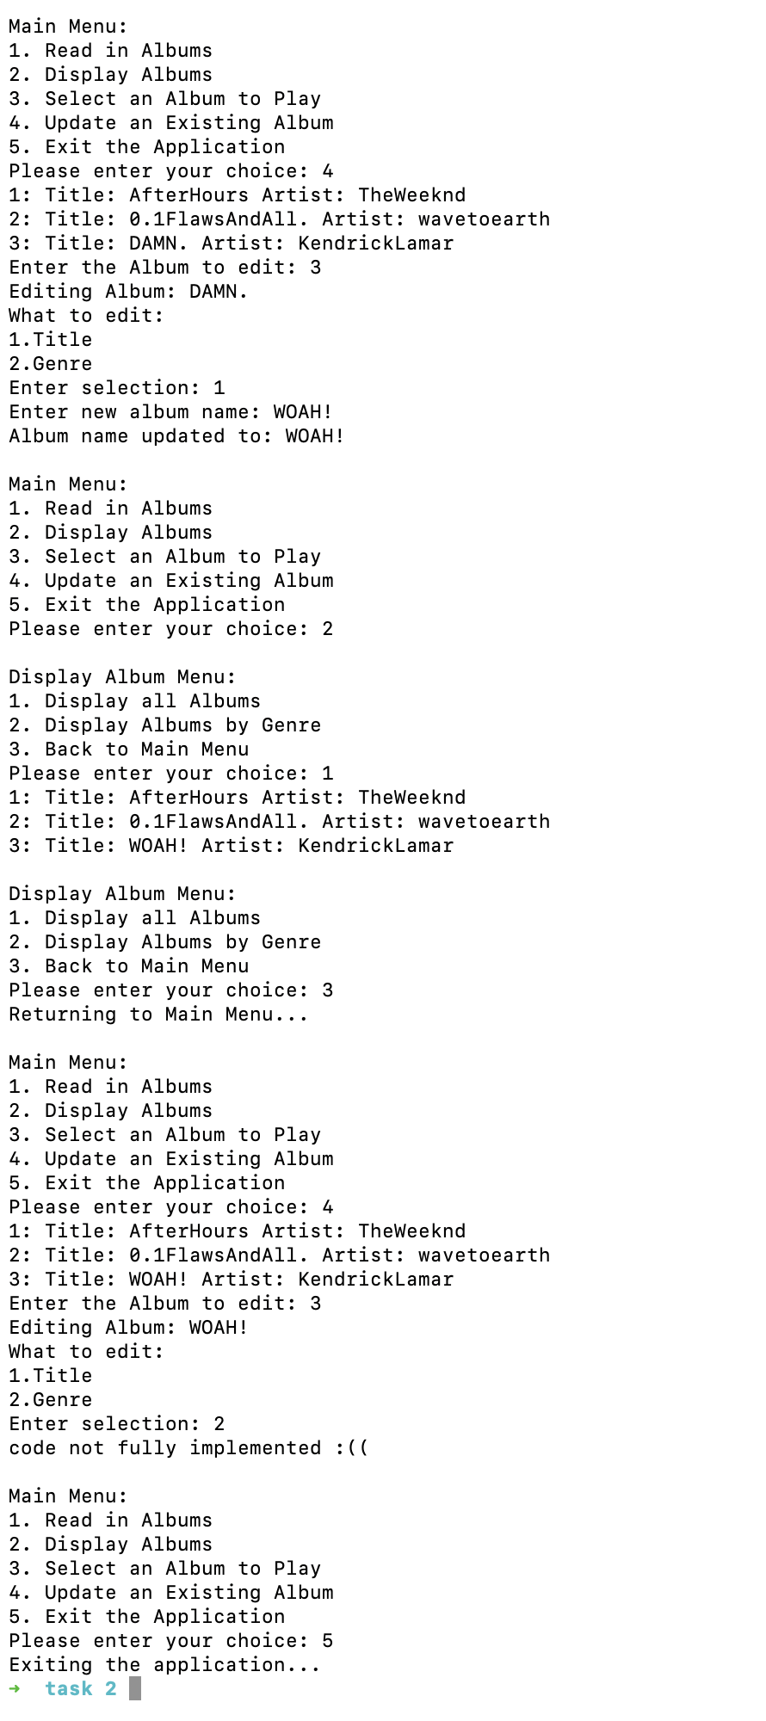

Question 3

Program description

This C++ program creates a program with “splashkit” that shows the user a screen and 3 buttons on top with 3 different functions, to draw bars, to use bubble sort, and to use selection sort. The program should generate 800 different bars of random colour and height.

IMPORTANT: DON’T GIVE THE SCREENSHOT OF THE CODE (COPY AND PASTE THE CODE)

#include <iostream>
#include <cstdlib>
#include <ctime>
#include "splashkit.h"
#define SIZE 800 // amount of bars on the screen
using namespace std;

struct sample
{
int value;
color clr;
};

color get_color(float num)
{
float hue = num / float(screen_height());
return hsb_color(hue, 0.7, 0.8); // hsb color is used to change the hues of color on the bars
}

// randomizes the height and color of the bars
void fill_array(sample data[])
{
for(int i = 0; i < SIZE; i++)
{
data[i].value = rand() % (screen_height() -100);
data[i].clr = get_color(data[i].value);
}
}

// draws the bars
void draw_bar(sample data[])
{
float rect_width = 800.0 / SIZE;
for(int i = 0; i < SIZE; i++)
{
float x = rect_width * i;
float y = screen_height() - data[i].value;
fill_rectangle(data[i].clr, x, y, rect_width, data[i].value);
}
}

// the red line above the bars
void draw_red_line()
{
draw_line(COLOR_RED, 0, 50, screen_width(), 50);
}

// draws the buttons
void draw_buttons()
{
fill_rectangle(COLOR_GREEN, 50, 10, 100, 30);
fill_rectangle(COLOR_GREEN, 200, 10, 100, 30);
fill_rectangle(COLOR_GREEN, 350, 10, 100, 30);
draw_text("Draw Bars", COLOR_WHITE, 60, 15);
draw_text("Sort 1", COLOR_WHITE, 225, 15);
draw_text("Sort 2", COLOR_WHITE, 375, 15);
}

// bubblesort function
void BubbleSort(sample data[], int array_size)
{
int i, j;
sample temp; // declare 'temp' as a struct to hold both 'value' and 'clr'

for (i = 0; i < (array_size - 1); i++)
{
for (j = 0; j < array_size - 1 - i; j++)
{
if (data[j].value > data[j+1].value) // compare the 'value' field of the struct
{
temp = data[j+1]; // swap the entire struct
data[j+1] = data[j];
data[j] = temp;
}
}
}
}

void SelectionSort(sample data[], int array_size)
{
int i, j, min_idx;
sample temp; // declare 'temp' as 'sample' to store both 'value' and 'clr'

for (i = 0; i < array_size - 1; i++)
{
min_idx = i;

for (j = i + 1; j < array_size; j++)
{
if (data[j].value < data[min_idx].value) // compare based on the 'value' field
{
min_idx = j;
}
}

// swap the found minimum element with the first element
temp = data[min_idx]; // swap the entire struct (both 'value' and 'clr')
data[min_idx] = data[i];
data[i] = temp;
}
}

// function to click the buttons
void button_clicks(sample data[], bool &draw_bars)
{
if (mouse_clicked(LEFT_BUTTON))
{
if (mouse_x() > 50 && mouse_x() < 150 && mouse_y() > 10 && mouse_y() < 40)
{
fill_array(data);
draw_bars = true; // draws bar when button is pressed
}
else if (mouse_x() > 200 && mouse_x() < 300 && mouse_y() > 10 && mouse_y() < 40)
{
BubbleSort(data, SIZE);
}
// This condition should have functionality if needed
else if (mouse_x() > 350 && mouse_x() < 450 && mouse_y() > 10 && mouse_y() < 40)
{
SelectionSort(data, SIZE);
}
}
}

int main()
{
sample data[SIZE];
open_window("Array Rectangle", 800, 700);
srand(time(NULL));

bool draw_bars = false; // waits until button is pressed to draw bars
while(not quit_requested())
{
process_events();
clear_screen(COLOR_WHITE);
draw_buttons();
draw_red_line();
button_clicks(data, draw_bars);

if (draw_bars)
{
draw_bar(data);
}

refresh_screen(60);
}

return 0;
}

Screenshots showing working program (Show all possible outcome):
